**Smart Dustbin using Arduino, Ultrasonic Sensor & Servo Motor**

In this project, I will show you How to Make a Smart Dustbin using Arduino, where the lid of the dustbin will automatically open when you approach with trash. The other important components used to make this Smart Dustbin are an HC-04 Ultrasonic Sensor and an SG90 TowerPro Servo Motor.

**Introduction**

Dustbins (or Garbage bins, Trash Cans, whatever you call them) are small plastic (or metal) containers that are used to store trash (or waste) on a temporary basis. They are often used in homes, offices, streets, parks etc. to collect the waste.

In some places, littering is a serious offence and hence Public Waste Containers are the only way to dispose small waste.

Usually, it is a common practice to use separate bins for collecting wet or dry, recyclable or non-recyclable waste.

In this project, I have designed a simple system called Smart Dustbin using Arduino, Ultrasonic Sensor and Servo Motor, where the lid of the dustbin will automatically open itself upon detection of human hand.

**Concept behind Smart Dustbin using Arduino**

The main concept behind the Smart Dustbin using Arduino project is Object Detection. I have already used Ultrasonic Sensor in [**Object Avoiding Robot**](https://www.electronicshub.org/obstacle-avoiding-robot-arduino/), where upon detecting an object, the Robot will change its course of direction.

A similar methodology is implemented here, where the Ultrasonic Sensor is placed on top of the dustbin’s lid and when the sensor detects any object like a human hand, it will trigger Arduino to open the lid.

**Code**

The code for the project How to Smart Dustbin using Arduino is given below.

|  |  |
| --- | --- |
|  | #include <Servo.h> |
|  | Servo myservo; |
|  | int pos = 20; |
|  | const int trigPin = 5; |
|  | const int echoPin = 6; |
|  | const int led = 13; |
|  |  |
|  | long duration; |
|  | float distance; |
|  |  |
|  | void setup() |
|  | { |
|  | myservo.attach(11); |
|  | pinMode(trigPin, OUTPUT); |
|  | pinMode(echoPin, INPUT); |
|  | pinMode(led, OUTPUT); |
|  | myservo.write(pos); |
|  | } |
|  |  |
|  | void loop() |
|  | { |
|  | //Serial.begin(9600); |
|  | digitalWrite(trigPin, LOW); |
|  | delayMicroseconds(2); |
|  | digitalWrite(trigPin, HIGH); |
|  | delayMicroseconds(10); |
|  | digitalWrite(trigPin, LOW); |
|  |  |
|  | duration = pulseIn(echoPin, HIGH); |
|  | distance = 0.034*(duration/2); |
|  | //Serial.println(distance); |
|  | if (distance < 27) |
|  | { |
|  | digitalWrite(led,HIGH); |
|  | myservo.write(pos+160); |
|  | delay(1000); |
|  | } |
|  | else |
|  | { |
|  | digitalWrite(led,LOW); |
|  | myservo.write(pos); |
|  | } |
|  | delay(300); |
|  | } |

**Working**

After setting up the Smart Dustbin and making all the necessary connections, upload the code to Arduino and provide 5V power supply to the circuit. Once the system is powered ON, Arduino keeps monitoring for any object near the Ultrasonic Sensor.

If the Ultrasonic Sensor detects any object like a hand for example, Arduino calculates its distance and if it less than a certain predefined value, Arduino will activate the Servo Motor and with the support of the extended arm, it will list the lid open.

After certain time, the lid is automatically closed.

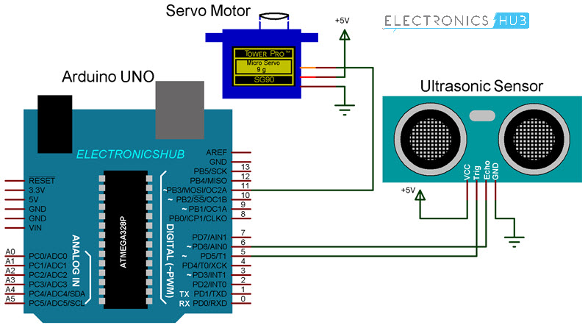

***Components Required***

* Arduino UNO
* HC-SR04 Ultrasonic Sensor Module
* TowerPro SG90 Servo Motor
* Connecting Wires
* 5V Power Supply
* A small dustbin with hinged lid
* Miscellaneous (glue, plastic tube, etc.)